Day 2

10/8/2023

Git is an open source tool which help to track or record changes done in application

Git provide local repository.

Git hub : Git hub is an open source Remote repository provided by Micro soft.

Git git hub

Provide local repository Git hub provide remote repository

We can use different type of remote repository

Ie Git hub

Git lab

Bit bucket

AWS : Code commit

Azure

Google cloud

Private cloud

Remote repository provided they can provide public as well as private repository.

Please create git hub account.

git remote add origin RemoteRepositoryURL it is use to connect local repository with

remote repository

git push -u origin main this command is use to push the code from

u : upstream data local to remote.

git remote -v it will provide remote repository details in local repository.

Git hub support lot of different types of authentication mode.

1. Token base authentication to push the code from local to remote.

Generate the token

git remote remove origin it is use to disconnect local with remote repository.

Steps to push the code from local repository to remote repository

1. Create the folder
2. Then create more than one file using any command or GUI with some contents.
3. Then make this folder as local repository so open the terminal

And type the command as git init

1. To verify this folder as local repository or not write command as ls -a
2. git status to check current status of repository
3. git add . to add all files or folder from file system to stagging area.
4. git commit -m “commit message” to push the code from stagging area to local repository
5. git branch -M main ( by default branch is master rename to main)
6. now create remote repository
7. please create the token
8. connect local repository with remote repository

git remote add origin <https://token@github.com/username/repositoryname>

1. git remote -v : this command is use to display remote repository URL.
2. If anything go wrong please remove remote repository url using command as

git remote remove origin

1. git push -u origin branchName ie master or main

(local branch name)

If we want to download any public repository in local machine.(Virtual Lab)

Create the folder : TrainerRepository

Then open terminal inside that folder and run the command as

git clone URL it is use to download public repository code in local machine.

git clone https://github.com/Kaleakash/test121212

After clone using ls command verify folder name

ls

test121212

cd test121212

git pull this command you need to run inside repository folder.

It will pull new changes done in remote repository.

git push -u origin main (please run this command insider trainer repository ie test121212)

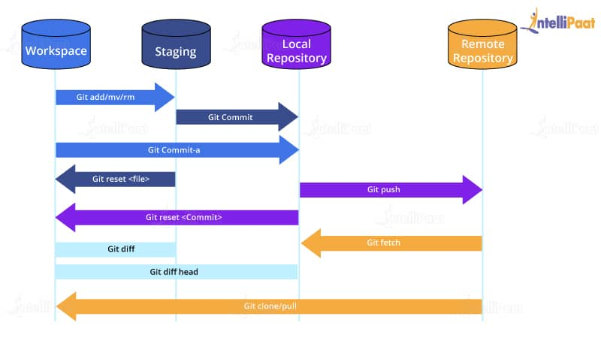

Git fork : it is use to create the copy of remote repository folder without effecting actual repository.

Hello

After fork

Please clone repository in your local machine.

git clone URL

ls

test121212

cd test121212 move inside a folder

create new file or do some task

main

git add .

git commit -m “done”

git push -u origin main

git remote remove origin

git add remote origin <https://YourToken@github.com/YourName/test121212.git>

git push -u origin main

clone : creating copy of remote repository in local machine or local repository

fork : creating copy of remote repository in remote machine or git hub without effect actual repository code.